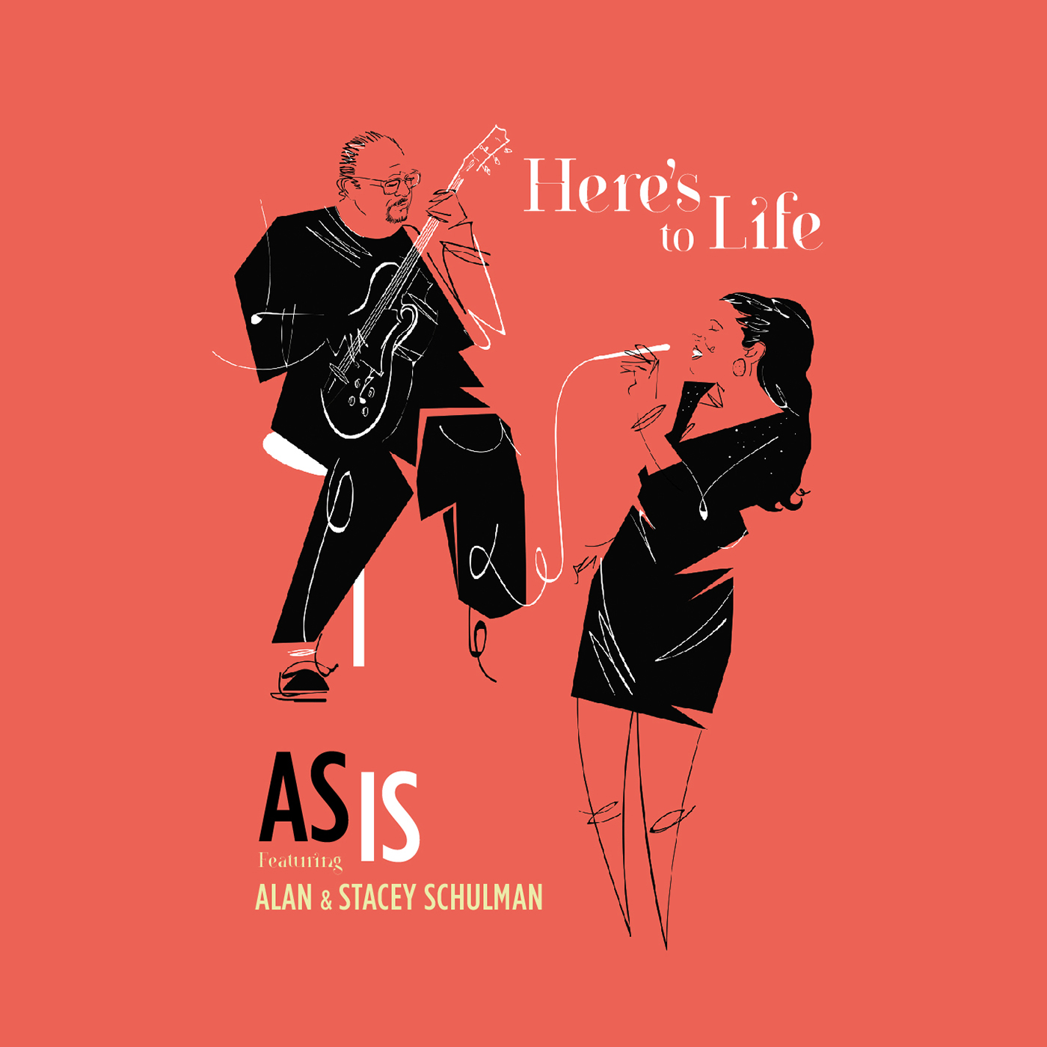
HERE’S TO LIFE, the newest CD by AS IS, featuring jazz guitarist ALAN SCHULMAN and jazz vocalist STACEY SCHULMAN, is an eclectic mix of tunes that showcases Stacey’s versatile vocal stylings and Alan’s soulful acoustic and electric jazz guitar playing. The CD is a testament to the creativity and exploratory resilience of artists who refuse to settle for hackneyed tropes.
Surprises abound on this CD. Whether the duo tackles pop tunes like “Save Your Love for Me,” Janis Ian’s “Some People’s Lives,” Stevie Wonder’s “Overjoyed,” or music by Gershwin or Dizzy Gillespie, Stacey and Alan imbue each song with their own highly original musical perspectives.
The jazz group AS IS has been performing in the New York City area since 2005. Alan Schulman is a noted jazz guitarist from Cincinnati, Ohio who studied with the late great guitarist Cal Collins (formerly of the Benny Goodman Orchestra). He holds a Masters degree in Jazz Arranging & Composition from Howard University in Washington DC. A Thelonius Monk Competition Top-10 finalist, he has appeared with such noted jazz artists as Anita Baker, Herbie Hancock, Wynton Marsalis & Michael Feinstein. Stacey Schulman is a jazz vocal stylist and a native of the New York City area, performing in a variety of musical and theatrical roles since the age of nine. As an NYC studio singer, Stacey has had the privilege of singing on radio commercials, television series and movie soundtracks throughout her 20+ year musical career.
AS IS released their debut CD, "A Love Like Ours", on May 22, 2015, donating all proceeds of the CD's sale to the Global Lyme Alliance to raise awareness about Lyme Disease and support Chronic Lyme Disease research. The couple’s cover single “Summertime” was featured prominently in a Global Lyme Alliance PSA commercial radio campaign in the United States throughout the summer of 2015, with over 3500 plays. Stacey is a survivor of Lyme Disease and a vocal advocate for funding, research and awareness of the disease.
​
“A Love Like Ours” was the #1 Best Seller in the Vocal Jazz category on Amazon.com in its first week of digital distribution. It was awarded “Best Jazz Album” honors in August 2015 by The Akademia and has been featured on Jonathan Schwartz’s Great American Songbook broadcast on WNYC in New York City and Jay Daniels' Simply Timeless show on NPR affiliates across the northeast.
​
AS IS is releasing their sophomore album this year with Grammy-nominated producer, James McKinney. Scheduled to be released on February 16, 2018, the album blends the duo’s signature intimacy with the talents of special guest artists including Grammy-nominated drummer, Marcus Baylor (The Baylor Project, The Yellowjackets); acclaimed saxophonist, David Binney; harmonica virtuoso, Gregoire Maret; vocalese talents Christie Dashiell and Kokayi, and members of the Kennedy Center orchestra.
JRNE Artist Management, Joseph Pineda joseph@jrneartistmanagement.com

